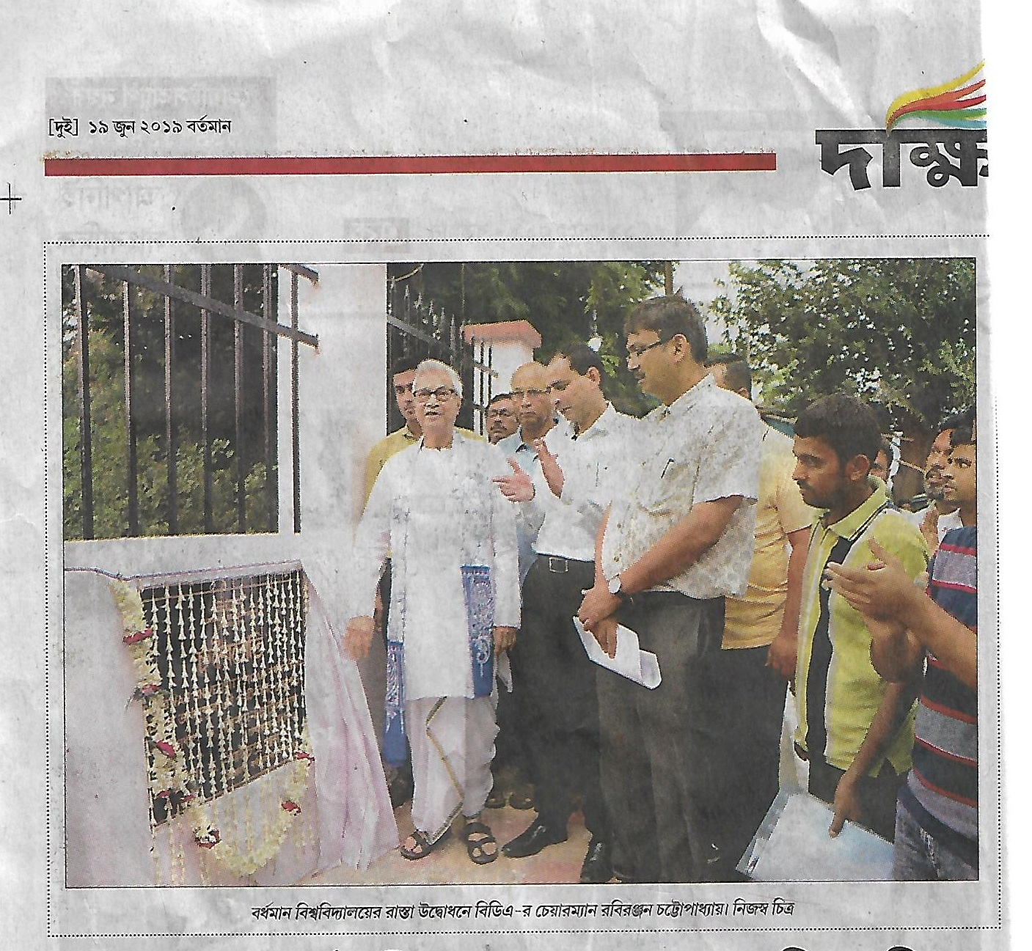
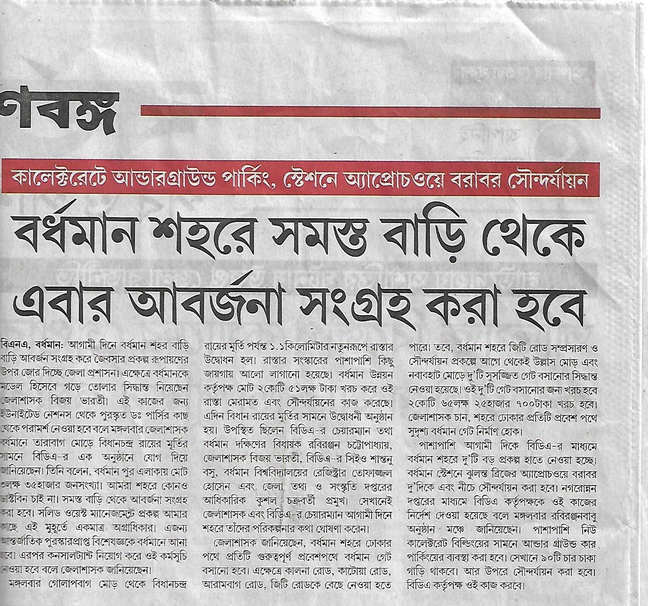
Inauguration of the BDA’s Scheme for “Development and Beautification of the “BURDWAN UNIVERSITY ROAD” ‘Q°lh¢a’ from Golapbag More to Bidhan Roy’s Statue, Burdwan on 18/06/2019 at 3:00 pm

